# 第2週回家功課:

(https://cad.onshape.com/documents/d4ac8f2b820f944b8b4517bc/w/3111b5bd47bc2420d1dbec3d/e/e81cfde06d5cf6d71b679a3e)以上Onshape的網址

使用下方尺寸建立下方幾何零件.需要零件圖PDF版,可以連結“[Drawings for Homework](https://drive.google.com/open?id=0B_Vi5ZdEzANgLXFPbGhLWmV5TWM)”.

## Exercise #1:

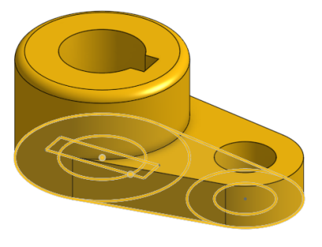

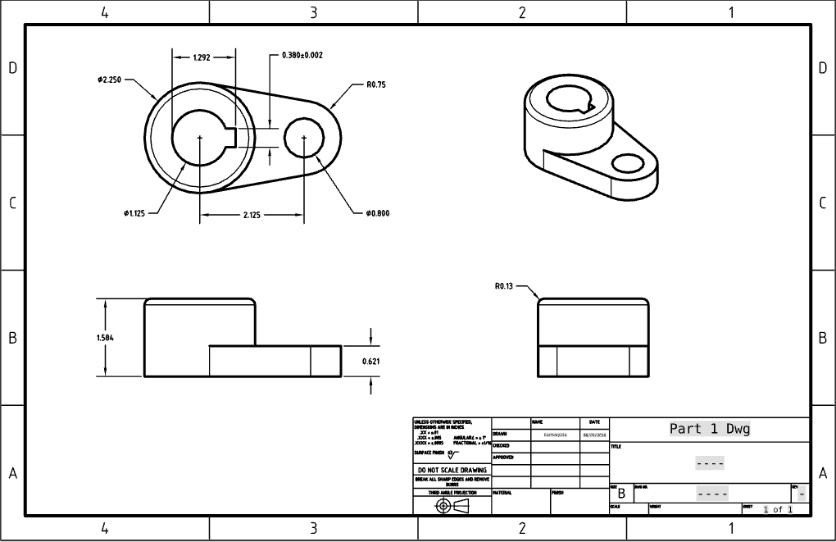

## Exercise #2:

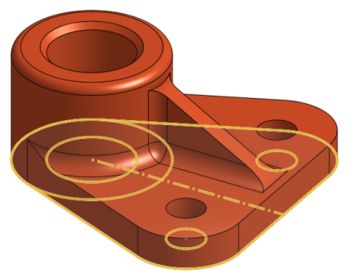 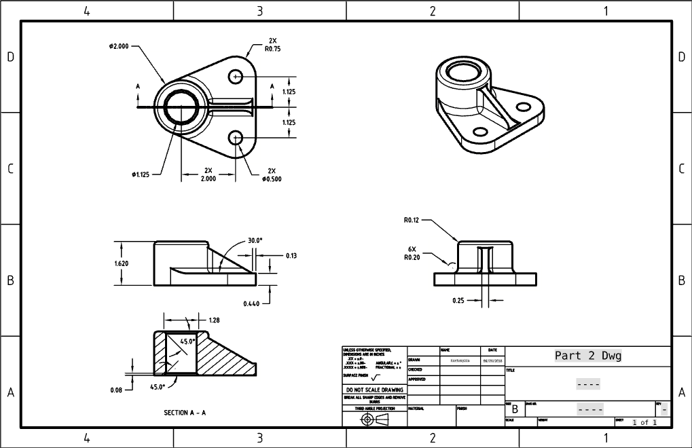

## Exercise #3:

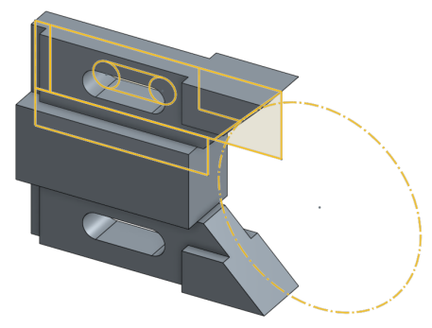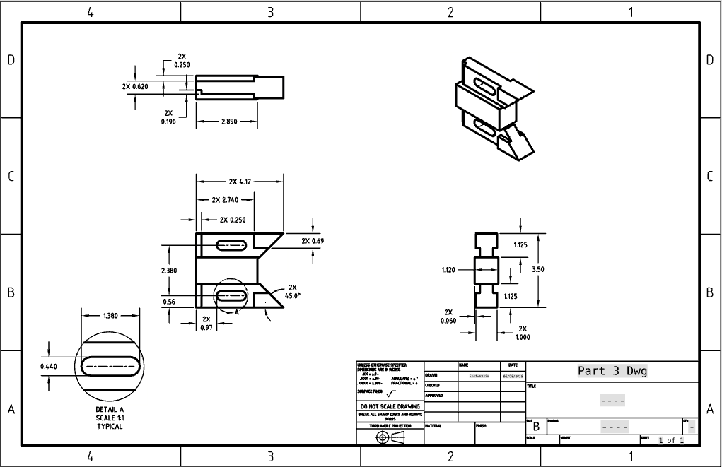

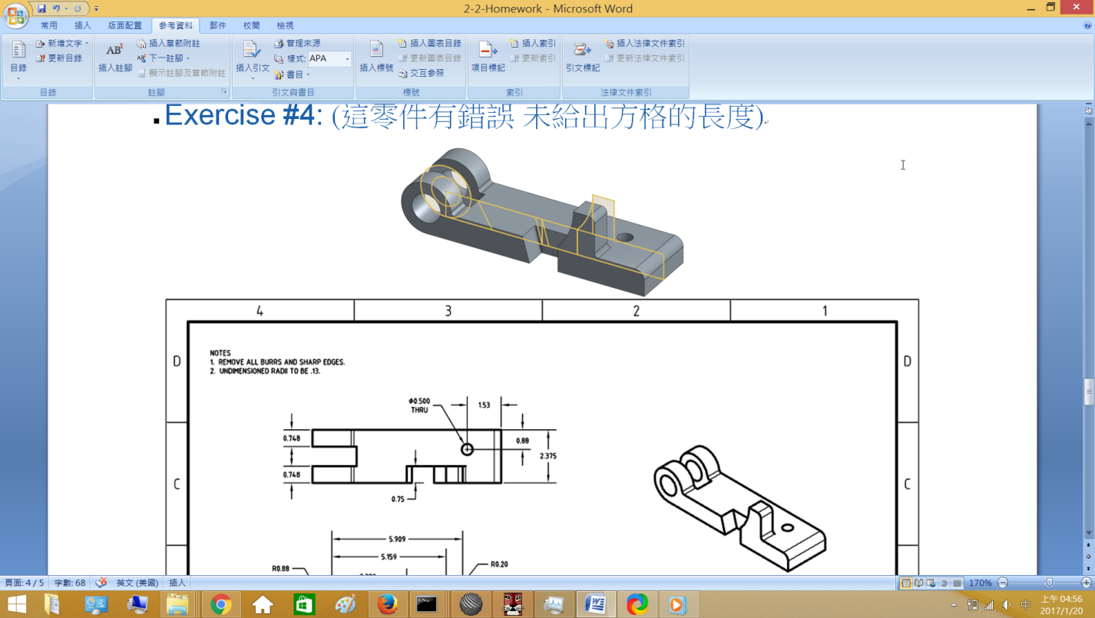

## Exercise #4: (這零件有錯誤 未給出方格的長度)

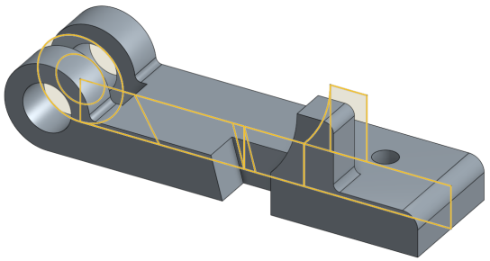 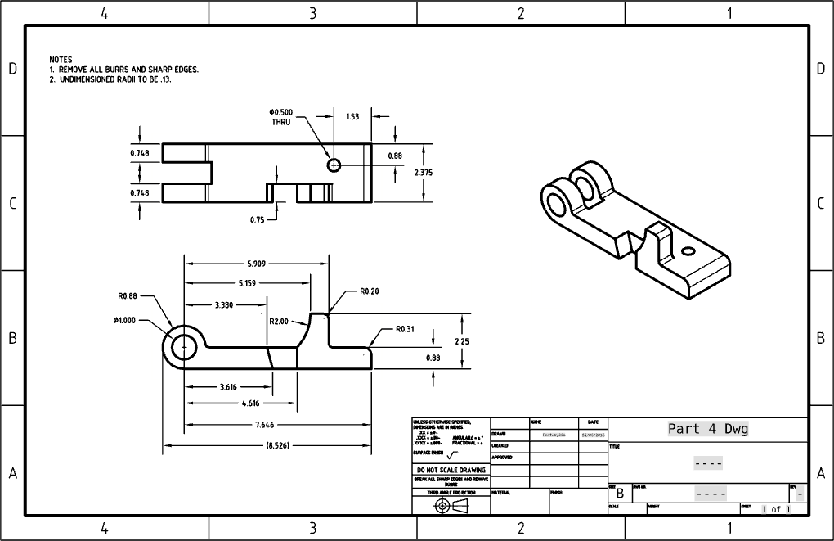

## Exercise #5:

